Investigation 9A: WESTERLIES AND THE JET STREAM
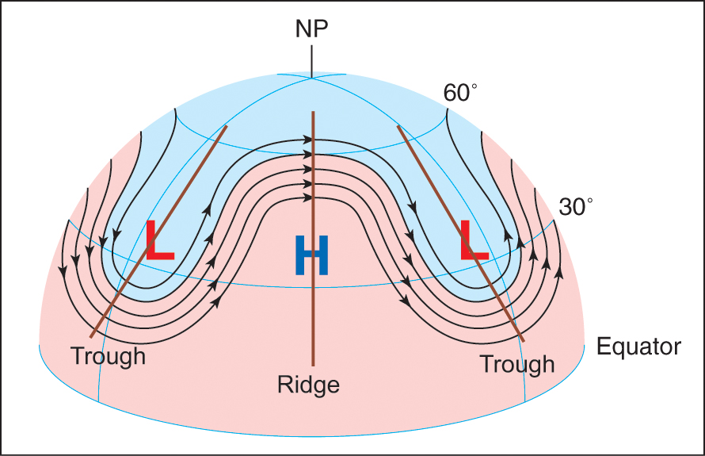

1. "The Northern Hemisphere’s upper-air westerlies flowing through topographical ridges exhibit clockwise (anticyclonic) curvature as seen from above. As shown in Figure 1, the ridge axis line divides the ridge into two roughly symmetrical sectors. Note that west of the ridge axis, winds are from the southwest (a warm weather direction) and east of the ridge axis, winds are from the northwest (a cold weather direction). We can conclude that winds to the west of a ridge axis favor ________ air advection while winds to the east of a ridge axis favor cold air advection."
- cold
- warm

2. "The Northern Hemisphere’s upper-air westerlies flowing through topographical troughs exhibit counterclockwise (cyclonic) curvature as seen from above. As shown in Figure 1, the trough axis line divides the trough into two roughly symmetrical sectors. Note that west of the trough axis, winds are from the northwest (a cold weather direction) and east of the trough line, winds are from the southwest (a warm weather direction). We conclude that winds west of a trough axis favor ________ air advection while winds east of a trough line favor warm air advection."
- cold
- warm

3. "Upper-air winds steer low-pressure systems as well as air masses. A surface Low that is centered to the east of a trough axis and west of a ridge axis will be expected to move toward the ________."
- southeast
- northeast

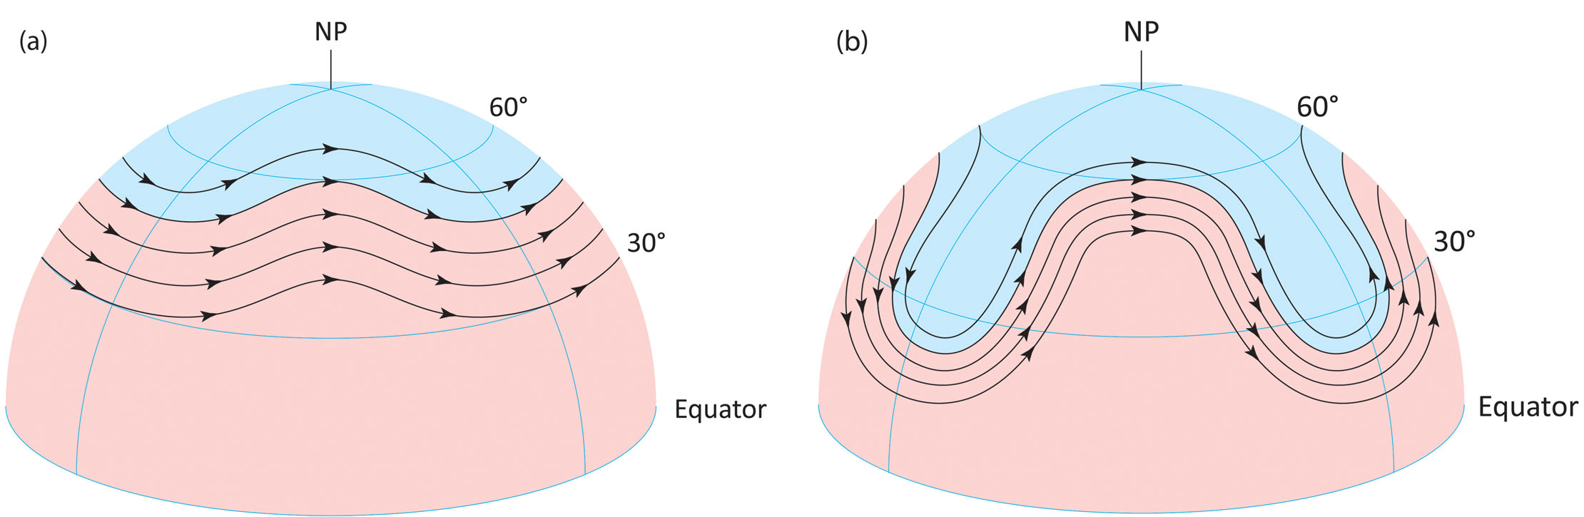

4. "When the upper-air flow pattern is zonal, the source region for much of the air over the coterminous U.S. is the Pacific Ocean. On the other hand, when the upper-air flow pattern is meridional, the source regions for air masses over the lower 48 states are Canada (where winds are from the northwest) or Mexico or the Gulf of Mexico (where winds are from the southwest). Hence, from west to east across the lower 48 states, temperatures are likely to be more variable with a ________ flow pattern."
- meridional
- zonal

5. "Fundamental to the formation of the polar-front jet stream within the westerlies is the physical property that warm air is less dense than cold air when both are at the same pressure. Air pressure drops ________ rapidly with increasing altitude in cold air than in warm air."
- less
- more

6. "In the Northern Hemisphere, when the polar-front jet stream is south of a locality, the weather at that location is relatively ________."
- warm
- cold

7. "As a component of the planetary-scale upper-air westerlies and similar to the winds at 500 mb, the polar-front jet stream steers low pressure systems. Hence, middle latitude storms generally move from ________."
- east to west
- west to east

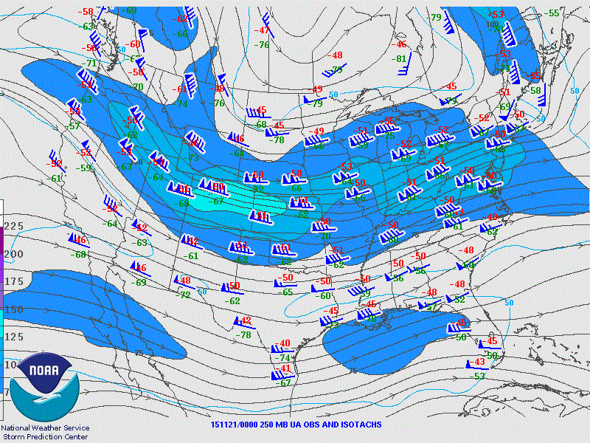

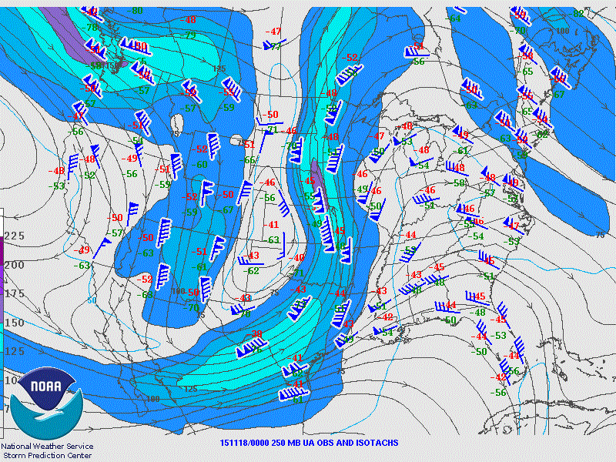

8. "The pattern of winds in Figure 4 indicates a ________ over the central U.S. states. The flow pattern across the country is meridional."
- ridge
- trough

9. "On average, one would expect temperatures at similar latitudes to be similar. Zonal wind patterns, as in Figure 3, would exhibit this relationship. However, given the wind pattern of Figure 4, at 00Z on 18 NOV 2015, surface air temperatures in the central plains states of South Dakota and Nebraska are likely to be ________ than surface temperatures over Ohio and Kentucky."
- lower
- higher

10. "Knowledge of the location of the jet stream and upper-air winds in general is very important for commercial aviation and can result in fuel savings and shorter flight times. At Figure 4 map time, an airline flight from Austin, Texas to International Falls, Minnesota would take ________ time than a flight along the same route from International Falls to Austin."
- less
- more

Applications

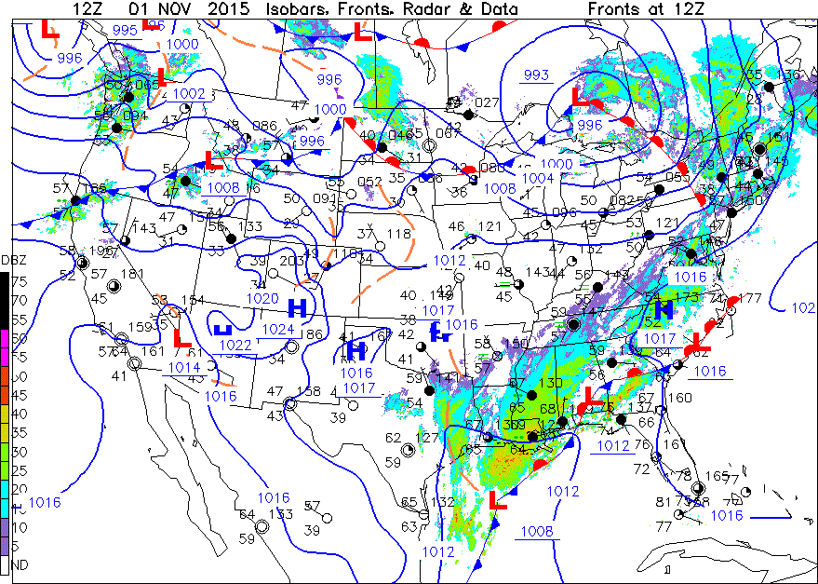

11. "Wind directions at station models near isobar lines across the country were generally seen to flow ________ with the circulation of the Ontario Low best defined as a low-pressure system."
- parallel to surface isobars
- at angles across isobars

12. "Surface wind speeds across the coterminous U.S. were generally less than Billings, in south central Montana, which reported a speed with three feathers denoting ________ knots."
- 15
- 30
- 50

13. "Figure 6 is the 500-mb constant-pressure map for 12Z 01 NOV 2015, the same time as the Figure 5 surface map. The mid-tropospheric flow pattern shown by the contour lines on the 500-mb map, displayed ________."
- a trough over the Great Lakes
- a closed circulation within a trough over Texas
- a generally west-to-east flow over the northwestern and north-central U.S.
- all of these features

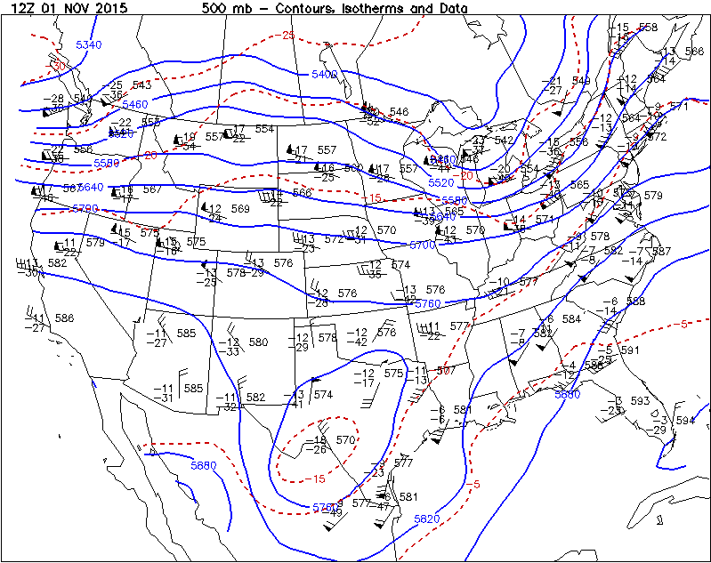

14. "Recall that the heights at which the radiosondes detected 500-mb of pressure are reported in the upper right position of the upper-air station models on the map. Also, the heights are plotted in tens of meters, so that a “0” needs to be added to the digits for the actual height. The height of the 500-mb pressure level plotted at Buffalo, in western New York, was ________ meters above sea level."
- 5420
- 5560
- 5630

15. "Compare the heights of the 500-mb pressure surface across the southern portion of the U.S. to those along the northern portion on the map. As latitude increases (one moves poleward), the height of the 500-mb surface generally ________."
- increases
- remains constant
- decreases

16. "The highest wind speeds plotted on the 500-mb map were reported at Buffalo. Those winds were generally from the southwest at about ________ knots (a pennant, four long and one short feathers)."
- 55
- 95
- 120

17. "The 500-mb wind directions often provide guidance on storm movements. The 500-mb wind directions over the Great Lakes region indicate the storm center seen on the Figure 5 surface map would generally move toward the ________ over the next day or so. The winds over the southern surface storm were generally light and mixed in direction, indicating little movement was expected."
- northwest
- northeast
- southeast
- southwest

18. "Figure 7 is the 300-mb constant-pressure map for 12Z 01 NOV 2015, the same time as the surface and 500-mb maps. The 300-mb pressure level occurs in the upper troposphere. The 300-mb station model heights are also plotted in tens of meters. The height of the 300-mb pressure level at Buffalo, NY, was ________ meters above sea level."
- 9290
- 9450
- 9770

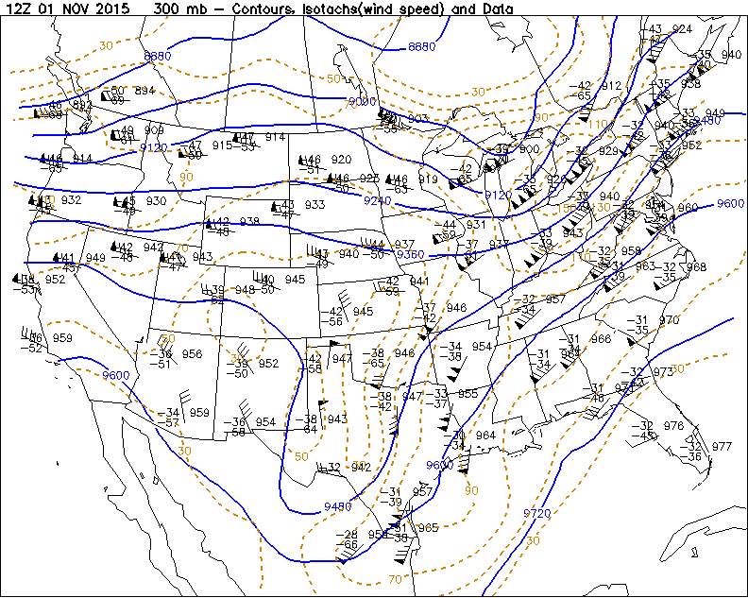

19. "The general 300-mb contour pattern at 12Z on 01 NOV exhibited an upper air flow with ________."
- a deep trough in the south-central U.S.
- a weak trough centered over the Great Lakes
- a generally west-to-east flow over the northwestern and north-central U.S.
- all of these features

20. "Comparing the heights of the 300-mb pressure surface generally across the southern portion of the U.S. to those along the northern portion on the map, as latitude increases (one moves poleward), the height of the 300-mb surface generally ________. This pattern is the same as that found at 500 mb."
- increases
- remains constant
- decreases

21. "From the 300-mb station models, the highest wind speed plotted on the Figure 7 map was at 155 knots at ________."
- Flagstaff, AZ
- Charleston, SC
- Buffalo, NY

22. "Survey the map for wind speeds of 70 knots or more. Using this arbitrary wind speed threshold to define the existence of a jet stream, we can therefore conclude that there ________ evidence of a jet stream on the Figure 7, 300-mb constant-pressure map curving across the U.S."
- was
- was not

23. "Now compare the wind speeds plotted on the 12Z 01 NOV 2015, 500-mb constant-pressure map (Figure 6) with those of the corresponding areas on the Figure 7, 300-mb map. The comparison implies that wind speeds typically ________ as altitude increases (upward to lower pressures) in the troposphere."
- decrease
- remain the same
- increase

24. "As was seen at the 500-mb constant-pressure level in Investigation 8B, higher wind speeds at 300 mb are also located where the spacings of height contours are relatively ________. Furthermore, the relationship is consistent with that on surface weather maps between wind speeds and the spacings of isobars."
- far apart
- close together

25. "Compare the 500-mb and 300-mb wind flows. The pattern of wind directions also shows that the winds generally flow ________. This directional relationship is particularly evident at higher wind speeds."
- “parallel” to the contour lines
- across contours at large angles

26. "Also note the relatively high wind speed area within the 90-kt isotach over the West Coast from Washington State to northern California extending eastward to western Montana. The wind speed at Medford, in southern Oregon, was plotted with two pennants and a half feather indicating ________ knots."
- 85
- 105
- 135

